**Downloading**

Navigate to: <https://www.soapui.org/downloads/soapui.html> and Get the open source version and do a clean Installation

After installing launch your SOAP UI

## Configuring

## First step in SOAP UI is to create a workspace. There can be several projects associated with a workspace. Users can create more than one workspace. In SOAP UI Pro version, we can seamlessly switch environments to map it to different end points.

* For Each project, we can create several test suites.
* For Each Test Suite, there can be several test cases attached to it.
* For Each Test Case, there can be several test steps associated with it.

Below is the pictorial representation of a workspace structure in SOAP-UI:

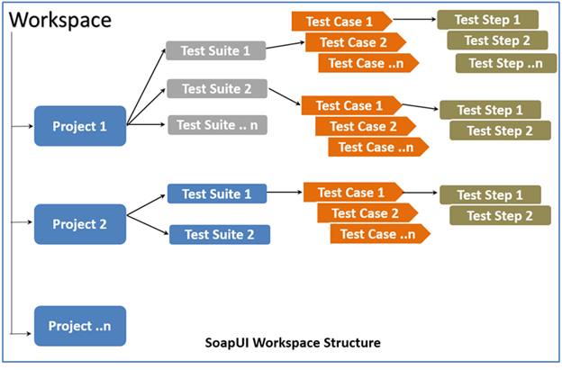

**Step 1:** First step is to create a workspace. Create a workspace as shown below. All the artifacts that we are going to create from now on would be contained in this workspace.

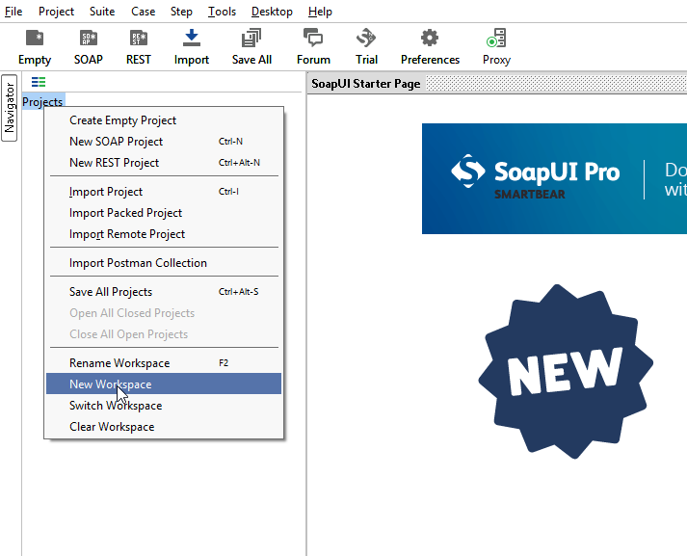

**Step 2:** Enter aname for the workspace and click 'OK.

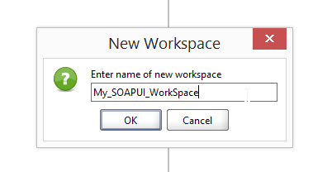

**Step 3:** Now the user has to select the path where this workspace has to be saved.

1. Select the path where the workspace has to be saved
2. The name of the workspace XML, which has to be located when user wants to open the workspace in the future.
3. Click 'Save'.

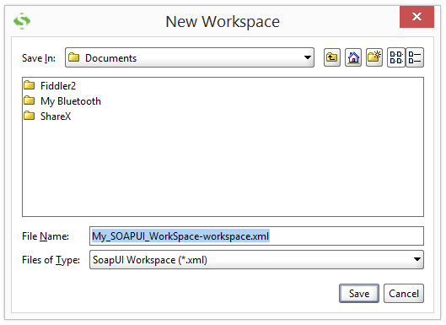

**Step 4:** The workspace is created as shown below. We can also access the workspace properties under 'Workspace Properties' Tab.

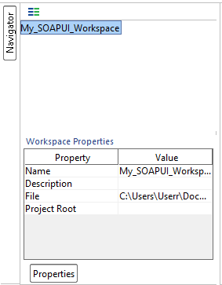

Now we have successfully configured SOAP-UI after downloading and installing such that we can continue to perform testing.

**FILE MENU:**

* Understanding the most frequently used navigations within SOAP-UI is very important for seamless navigation while working on real-time projects. Let us take a look at the file menu first.

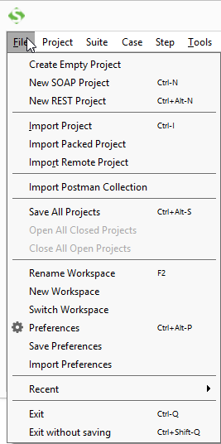

* 1. **'New SOAP Project'** allows user to create a Project by importing SOAP Request.
  2. **'New REST Project'** allows user to create a Project by importing REST Request.
  3. **'Import Project'** allows user to import the entire project by locating the corresponding XML.
  4. **'Save All Projects'** allows user to save all the opened projects in a single click.
  5. **'Close All Open Projects'** closes all the projects opened in that workspace.
  6. **'Rename Workspace'** allows user to rename the previously created workspace.
  7. **'Switch Workspace'** allows user to switch between workspaces.
  8. **'Preferences'** allows user to customize SOAP UI. We will deal with it in next section.

• ‘Save Preferences' allows user to save their customized settings. When SOAP UI opened for the next time, it uses the user saved preferences.

**FILE >> PREFERENCES >> HTTP SETTINGS:**

* Now, let us understand the 'Preferences' from the file menu. Upon Clicking 'Preferences' from 'File' Menu, the below dialog opens. We will go through the most frequently used 'HTTP Settings' in details.

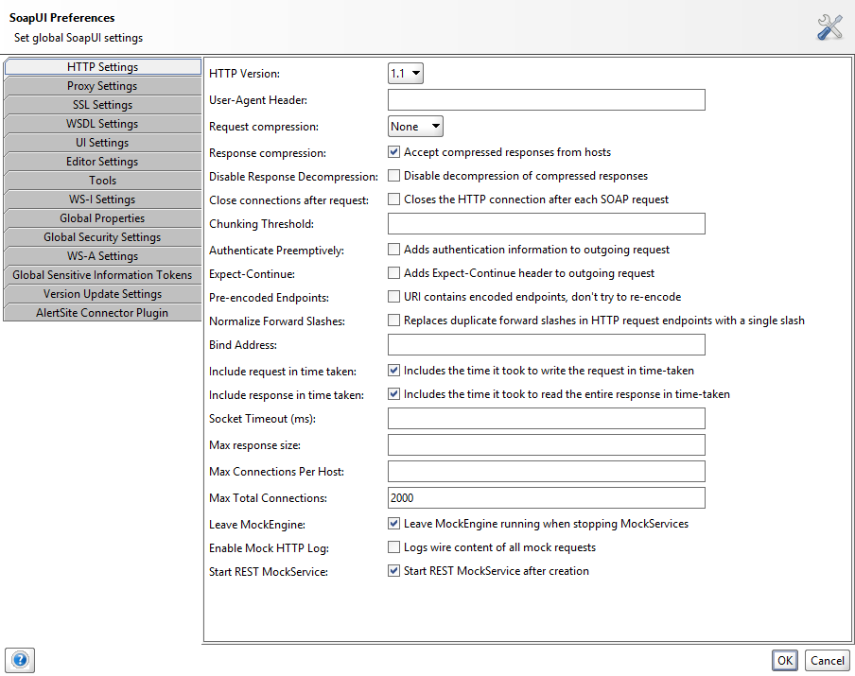

1. Denotes the **HTTP Version** to be used for request and response.
2. **'User-Agent Header**' allows user to can be predefined using this option. If not defined, it uses the default http client header.
3. **Request Compression** Allows user to specify the compression method. It can be either gzip or deflate or none.
4. 'If Checked', allows compressed response from hosts.
5. 'If Checked' disables decompression of the compressed responses.
6. 'If Checked' closes HTTP connection for each SOAP Request.
7. 'If Checked', allows user to specify authentication information for the outgoing requests.
8. Allows user to restrict the maximum number of bytes to be read from a response. ZERO corresponds to unlimited size.

**FILE >> PREFERENCES >> WSDL SETTINGS:**

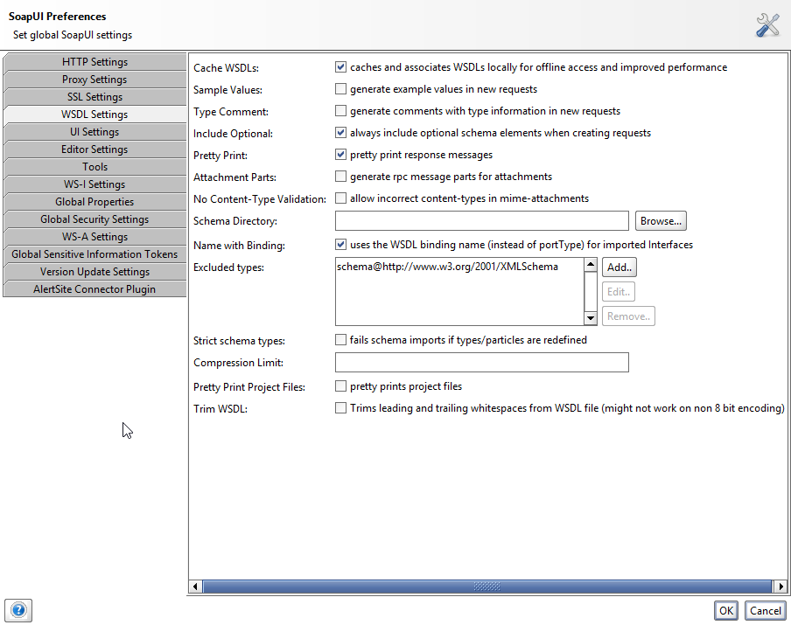

1. **Cache WSDLs** Turns on and off caching of WSDL's
2. **Generates example values in requests**
3. Allows users to always include optional elements in generated requests
4. Response messages are printed in the response editor
5. Allows user to specify a directory containing schema (.xsd) files while validating WSDL requests. Upon changing the contents of this directory SOAP UI requires a restart.
6. For the purpose of preserving space, the minimum message size to be compressed in the SoapUI project file.

**FILE >> PREFERENCES >> UI SETTINGS:**

* Now, we will go through the most frequently used 'UI Settings' in details.

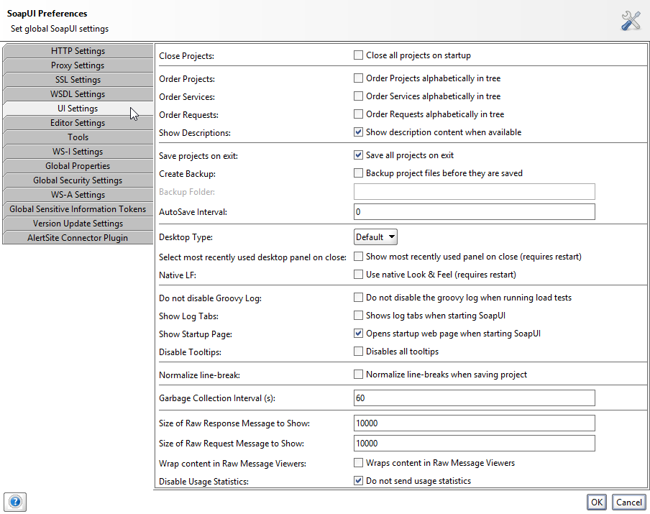

* 1. Closes all projects while launching SOAP UI for better startup-time and consumes less memory.
  2. Displays description whenever available.
  3. Automatically saves all projects while exiting SOAP UI.
  4. Before saving, SOAP UI creates a backup of the project. If enabled, back up folder has to be mentioned.
  5. Displays and expands the log tabs upon starting SOAP UI.
  6. Displays the 'start up page' dialog upon starting SOAP UI.
  7. Upon disabling tool tip, disables tool tip when user hovers mouse over the options/buttons while navigation.